**OS PROJECT-HYPERVISORS  
BENCHMARKS**

**Hdparm**

1. **Installing hdparm**

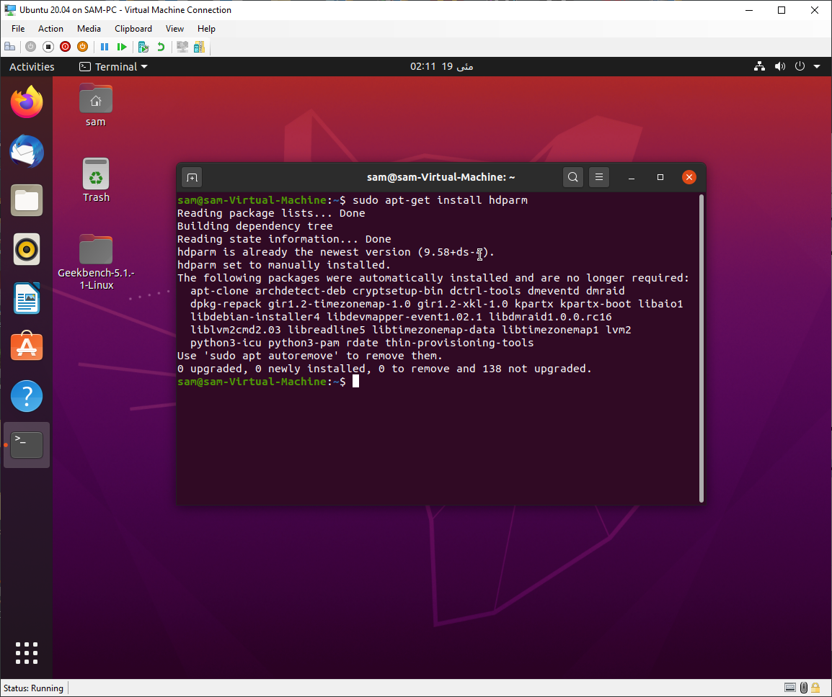

1. **HyperV results**

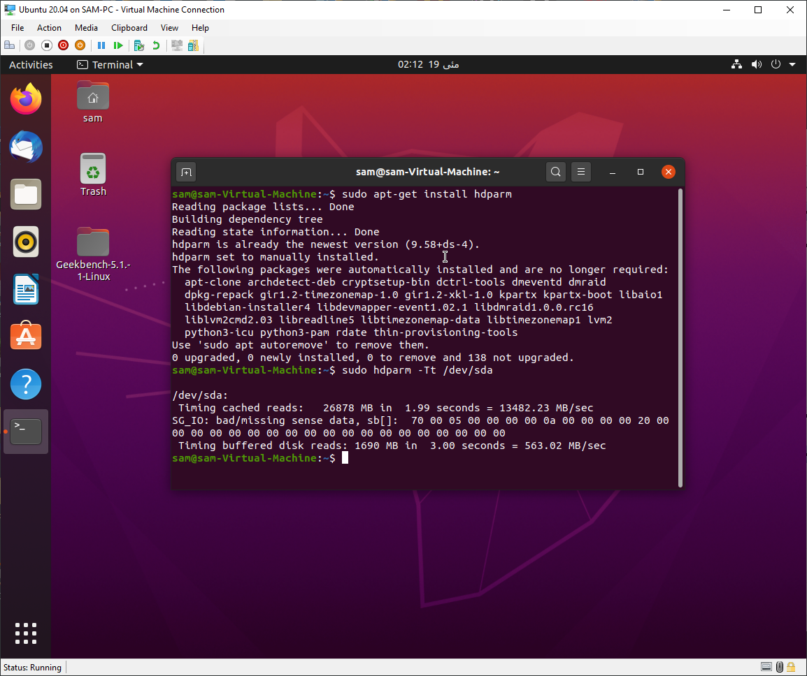

1. **VMware results**

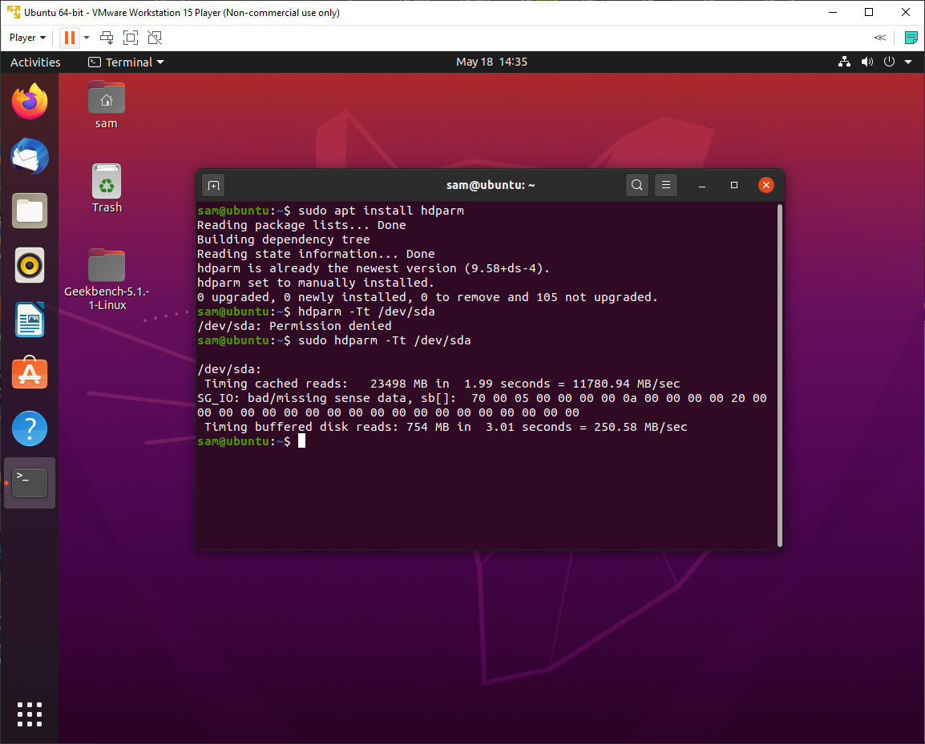

1. **VirtualBox results**

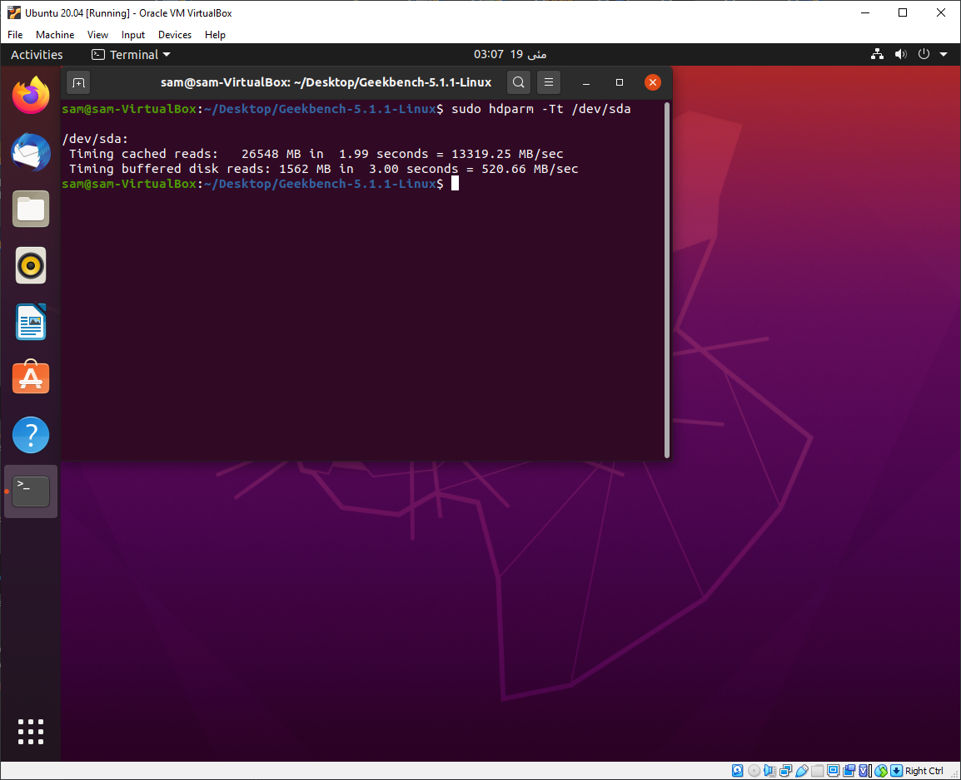

**Sysbench**

**Installing sysbench**

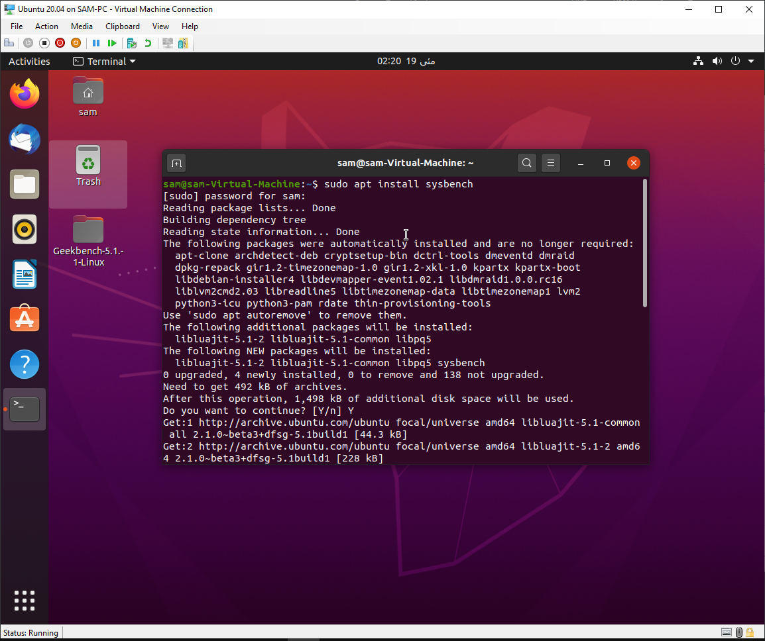

1. **CPU**
2. **HyperV results**

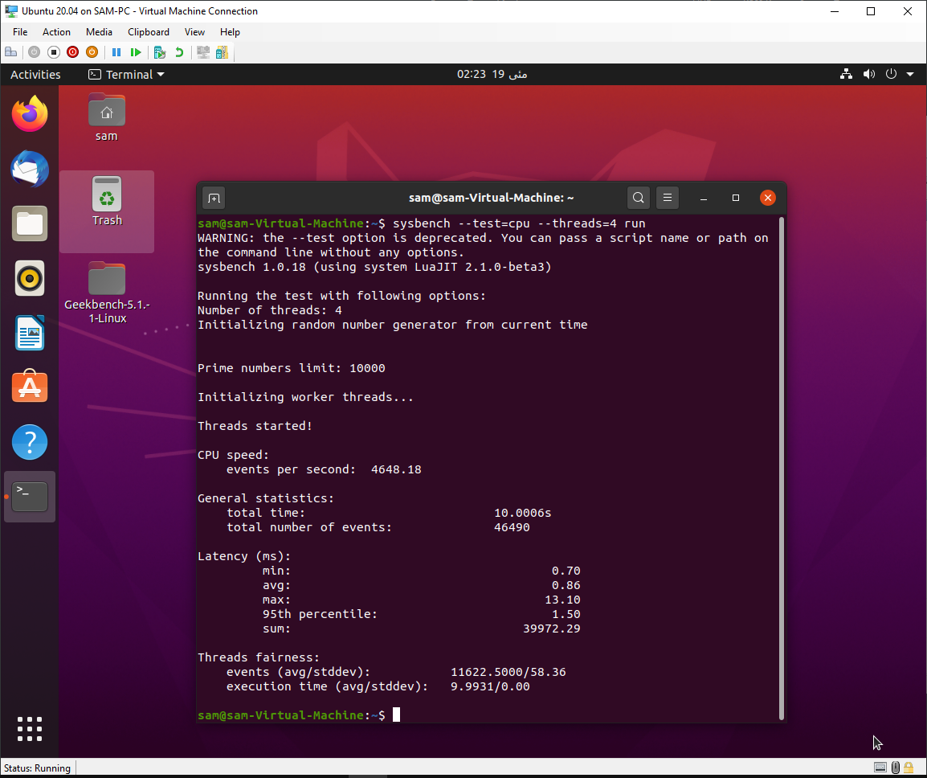

1. **VWware results**

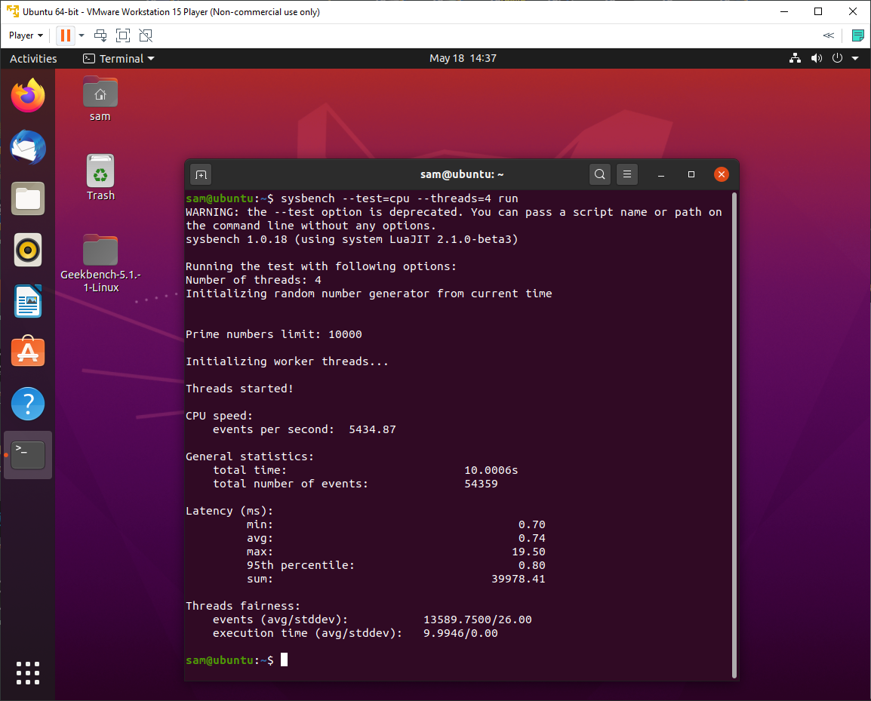

1. **Vbox results**

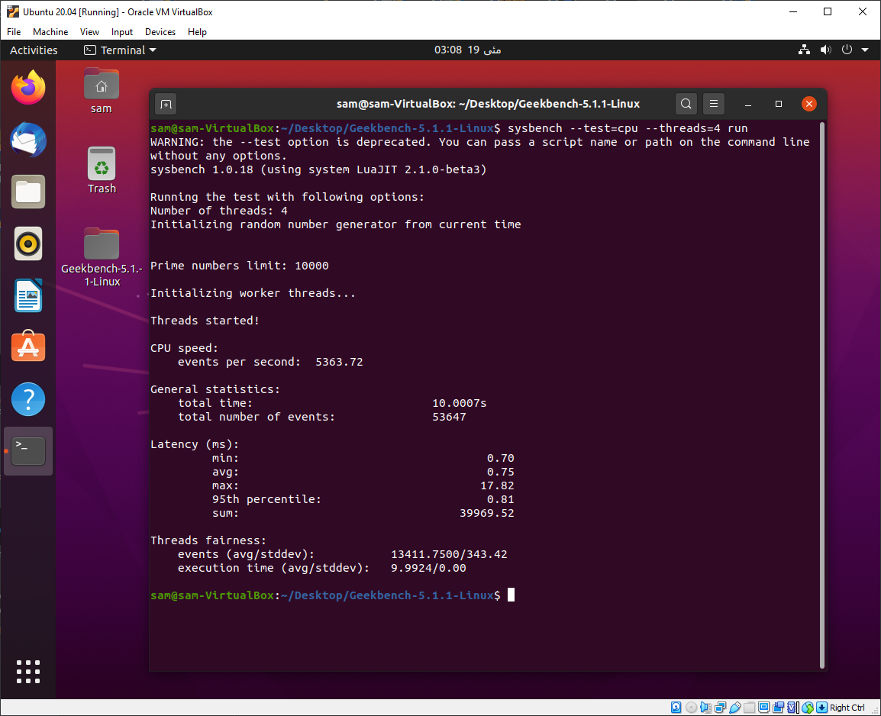

1. **Memory**
   1. **HyperV results**

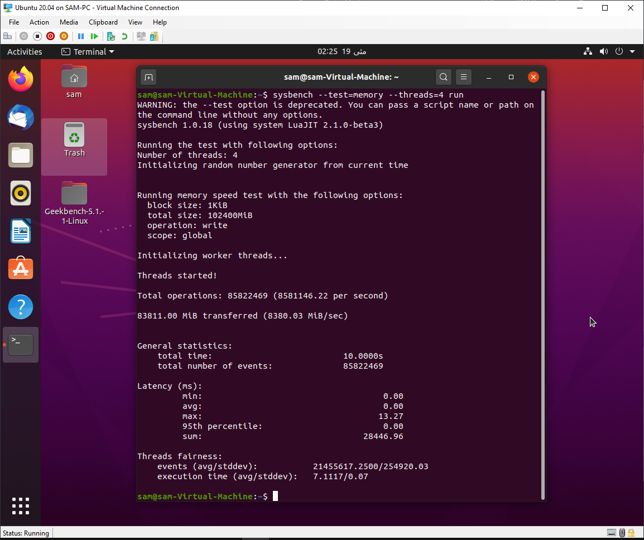

* 1. **VWware results**

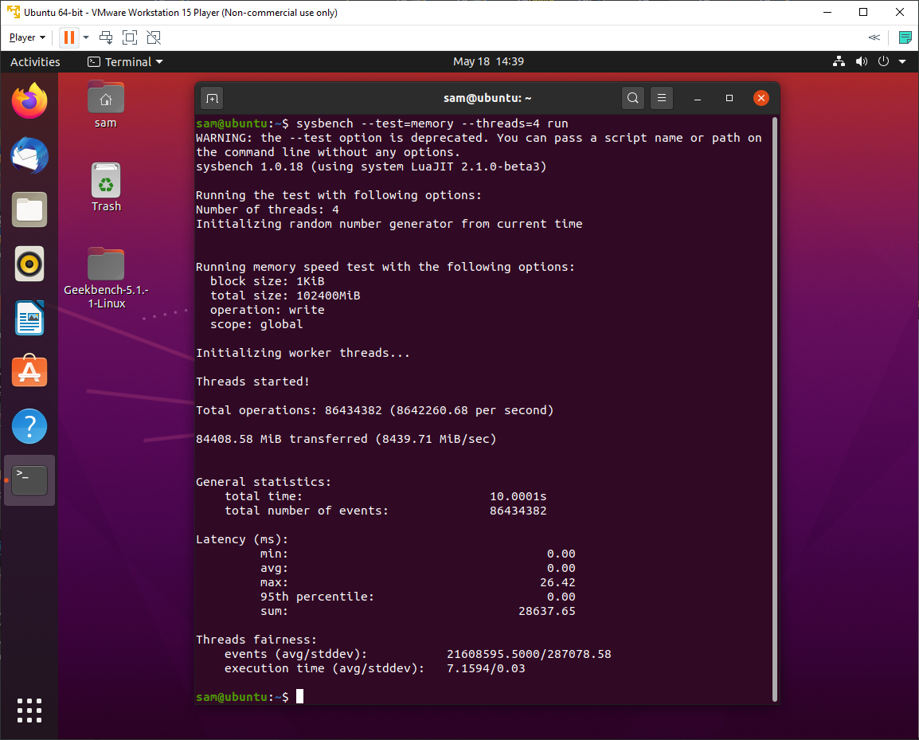

* 1. **Vbox results**

